**Visvesvaraya Technological University,**

**Jnana Sangama, Belagavi – 590 018**

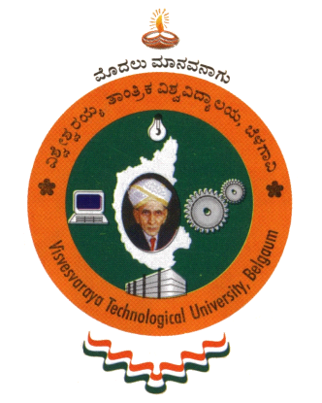

**Karnatak Law Society’s**

**Vishwanathrao Deshpande Institute of Technology, Haliyal – 581 329**

****

**Department of Electronics and Communication Engineering**

**Mini-Project Synopsis entitled**

Self-Driving Car

Submitted by

**Sufeelahmad Katevadi –[2VD21EC414]**

**Aditya Irkal – [2VD21EC400]**

**Ummeumara Savantwadi –[2VD20EC060]**

**Karthik Sanglikar –[2VD21EC402]**

6thSemester

Under the guidance of

Dr. Arun L. Kakhandki

Department of Electronics and Communication Engineering

**Academic Year 2022 – 23**

**Self-Driving car**

**Abstract:-**

Road safety is a critical concern worldwide, with millions of accidents occurring annually. To address this issue, researchers and engineers have been working on developing Intelligent Transportation Systems (ITS) that employ advanced technologies to improve road safety and efficiency. This paper presents an overview of the various components and technologies used communication, sensor networks, and intelligent algorithms. The primary focus is on how these technologies can enhance road safety by enabling real-time traffic monitoring, collision avoidance systems, and efficient traffic management. Additionally, the paper discusses the potential challenges and future prospects of ITS, including the integration of autonomous vehicles, data privacy concerns, and regulatory frameworks.

**Introduction:-**

Self-driving cars, also known as autonomous vehicles, are revolutionizing the automotive industry and transforming the way we commute. These vehicles can navigate and operate on roads without human intervention, relying on advanced technologies such as computer vision, machine learning, and sensor integration. In recent years, there has been a surge in do-it-yourself (DIY) projects involving self-driving cars, and one popular platform for such projects is the Raspberry Pi, specifically .The Raspberry Pi is a credit card-sized, low-cost, single-board computer that offers considerable computing power and flexibility. It has become a favorite among hobbyists and makers due to its ease of use and vast community support. When combined with open-source computer vision libraries like OpenCV, the Raspberry Pi becomes a powerful tool for developing self-driving car applications. The integration of a Raspberry Pi with OpenCV allows enthusiasts to create their own self-driving car prototypes, experimenting with computer vision algorithms, image processing, and control systems. By leveraging the capabilities of the Raspberry Pi and OpenCV, individuals can gain hands-on experience in the field of autonomous vehicles, contributing to the advancement of self-driving technology.

# Working:-

A self-driving car utilizing Raspberry Pi and OpenCV involves the integration of hardware components, such as a camera module and motor controller, with software algorithms powered by OpenCV. The Raspberry Pi board processes camera images, performs object detection and lane detection using OpenCV, and uses this information to make decisions regarding steering, acceleration, and braking. This combination of hardware and software enables the self-driving car to navigate autonomously.

# Objective:-

Design and develop a self-driving car system using Raspberry Pi and OpenCV to achieve full autonomy, enabling safe and efficient navigation, obstacle detection and avoidance, and adherence to traffic rules.

**Block Diagram:-**

# AI_Car_block.jfif

.

# FLOW CHART

**LANE DETECTION :-**

For detecting lanes, after image processing, we found the distance of the white pixels (255) from the left side of the ROI. For this, the pixels are treated like vectors to find their positions. The histogram is used for this purpose. If the distance of white pixels increases appropriate commands are sent to the Arduino UNO for taking the right turn. If the distance decreases it indicates the Arduino UNO to take the left turn. The degree of turn required is calibrated depending on the distance calculated.

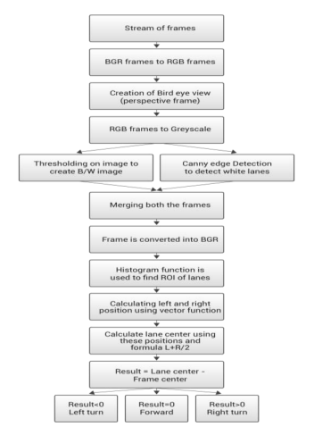

# OBJECT DETECTION :-

# Machine Learning comes into picture while performing object detection. First, we take samples of object to be detected. These are called the positive samples. Then wetake multiple images where our object to be detected is not present. These are the negative samples. For training and detection, we made use of Cascade Classifier software. After this, in the function for detecting the target object, various open CV methods are used for identifying the detected object and using distance formula(y=mx+c) we calculated the distance between the camera and the object by taking the distance and the pixels in the detected object as the parameters. Eventually, as the distance is known we created another function for halting the car within a desired range and by sending the command to Arduino UNO where it has algorithm for Stopping the car.

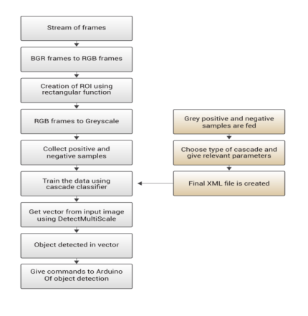

# Specification:-

Hardware requirement:

* Raspberry Pi
* Ultrasonic Sensor
* L298 Dual Channel H bridge
* Power bank
* Arduino

Software requirement:

* OpenCV
* Python

# Summary:-

Building a self-driving car using Raspberry Pi and OpenCV is a complex and challenging task that requires a deep understanding of robotics, computer vision, and software development. It involves setting up the necessary hardware components, installing and configuring the required software, acquiring and preprocessing data from a camera module, implementing lane detection and tracking algorithms, integrating a control system for steering and testing and refining the model.

# Reference :-

* Self-Driving Car using raspberry pi-Computer Vision Zone <https://www.computervision.zone/courses/self-driving-car-using-raspberry-pi/#login>
* OpenCV Self driving Car using Raspberry pi ,[Murtaza's Workshop - Robotics and AI](https://www.youtube.com/@murtazasworkshop)
* ImageAI. 2019. Official English Documentation for ImageAI!. https://imageai.readthedocs.io/en/latest/